Queensborough Community College

Electrical and Computer Engineering Technology

Course: ET-509 Section: F5

Instructor: Professor Brian Clark

Laboratory Experiment #8

Expressions and Interactivity

Created By: Joel Saquipulla

Date Executed: October 26, 2018

Date Handed In: October 26, 2018

Grade:

Objective

To become familiar with different commands to execute a program.

Description of Experiment

Using C++ create a printing program and a program with a variable.

Experiment 1.

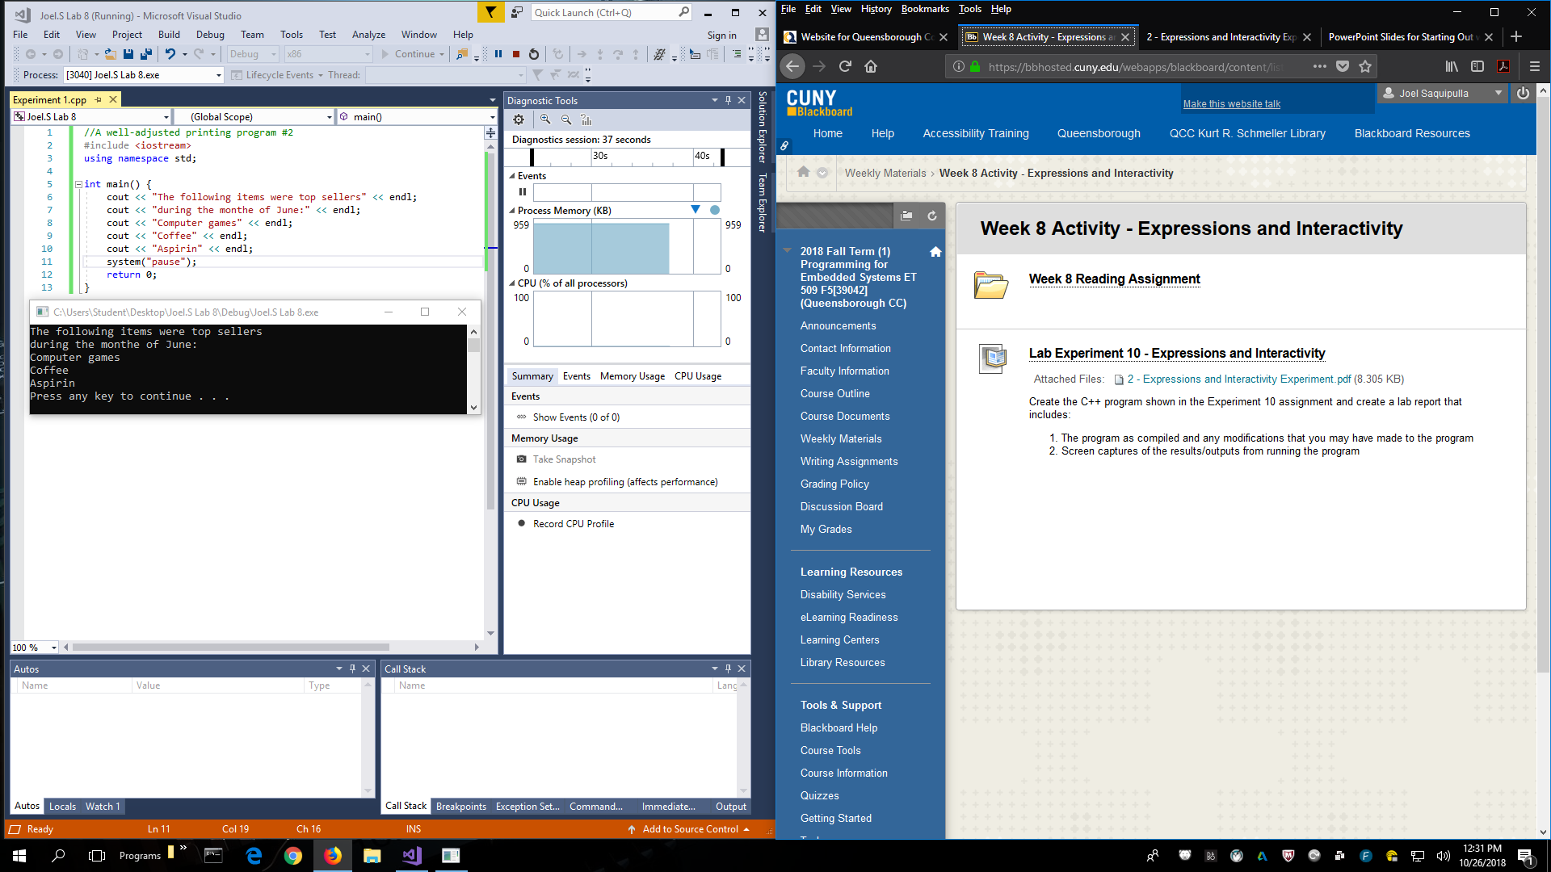

Experiment 2.

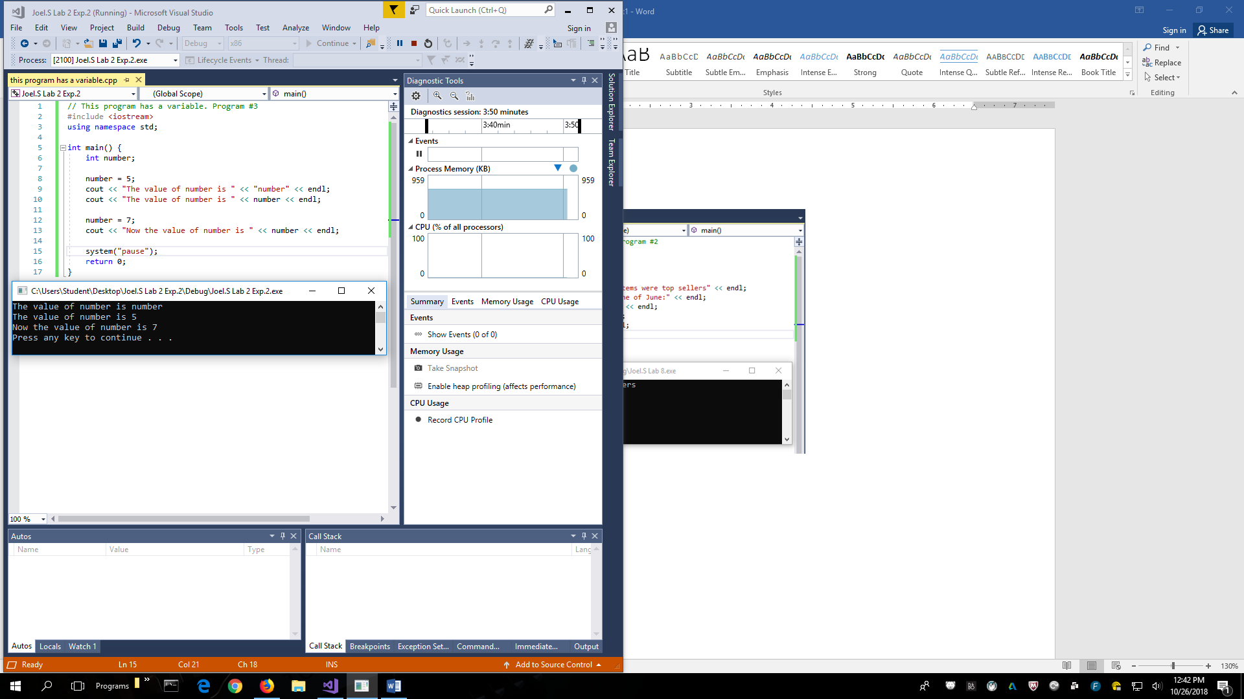

Conclusion

In this lab I’ve learned that “cout” implies that the code will print out on the debug window, “cin” requires an input from the user to assign a text or number to a string, character, or integer. But “#include <iostream>” must be used in order for “cout” and “cin” to work, called a preprocessor directive. To that “using namespace std” also has to be written, it holds definitions for variables, and functions. “int main()” means that every program must have a main function in order to run. “int” in front of it tells the compiler that the function will return an integer number. Then in order to properly execute a program the “;” must be put after certain pieces of code. It acts as a punctuation mark that separates major sentence elements.